Passing Large Data-sets to a Web Service
An Technique of Sending Bulk Data over HTTP
(Final Report)

By

John Avera
Florida Institute of Technology
CIS 5080 – Projects in Computer Information Systems

For

Mr. Steve Johnson
July 31, 2011

Table of Contents
Table of Contents 2
Introduction 3
Web Service Basics 3
SOAP Message Structure 4
DAWS Value Proposition 4
Algorithms / Project Solution 5
Message Transmission Optimization Mechanism (MTOM) 5
Base64 Encoding 6
XML-binary Optimized Packaging (XOP) 6
Multipurpose Internet Mail Extensions (MIME) 6
Implementation 7
Platform 7
Development Tools 7
Programming Language and Code Libraries 7
Implementation Procedure 7
Schedule 8
Results 9
Future Enhancements 11
References 12
Appendixes 13

Introduction
Data Access Web Service (DAWS) will distribute large datasets across the network using the Hyper-Text Transfer Protocol.
There are many applications that need access to large data sets such as logistical applications, climate reporting and analysis systems, and location services. Many techniques and current protocols are platform dependent and proprietary. Web Services offers an ability to send data over open standards that are platform independent. The issue with sending data as a web services is Hyper-Text Transfer Protocol (HTTP) used in web services is a stateless protocol. It is intended to send character data across the network as a request to a response without maintaining a connection from client to server. It was not intended to send large datasets. There is a technique; however, that is simple and maximizes current standards already in place to send bulk data-sets inside Simple Object Access Protocol (SOAP) messages. This project will provide a technique with algorithms of sending large data-sets to a web service to be consumed by a client and persisted on the client machine. It will also demonstrate a potential event-driven distributed system using the proposed data access web service.

Web Service Basics
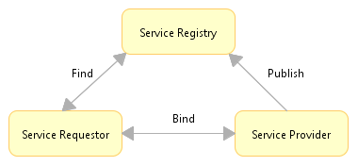
Web Services are typically Application Programming Interfaces (API) or Web APIs that can be accessed over a network, such as the Internet, and executed on a remote system hosting the requested services. A Web service is a software system designed to support interoperable machine-to-machine interaction over a network. It has an interface described in a machine-process able format (specifically Web Services Description Language (WSDL)). Other systems interact with the Web service in a manner prescribed by its description using SOAP messages, typically transmitted using HTTP with an Extensible Markup Language (XML) serialization in conjunction with other Web-related standards. A Service-Oriented Architecture (SOA) is a pattern realized thru web services, and is composed of three roles: service provider, service registry, and service requester that perform basic operations such as find, bind, and publish as shown in Figure 1.
Figure 1: Service-Oriented Architecture
The Service Provider is an organization (or individual) that provides services by creating, publishing, maintaining, and publishing their services. From a business perspective, the Service Provider owns the service, whereas from an architectural perspective, it is the platform that holds the implementation of the service.
The Service Registry provides a repository of service descriptions (WSDL). These descriptions are published by the service provider. Service Requesters will search the repository to identify the needed services and obtain the binding information for these services. A service registry can either be public or private.
The Service Requester is an organization (or individual) that looks for a service to fulfill its requirements. From a business perspective, it is a business that wants to consume a particular service. From a architectural perspective, it is an application that looks for and invokes a service.

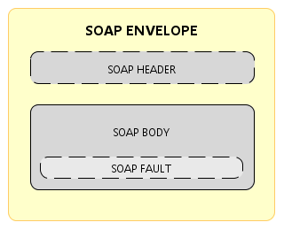
SOAP Message Structure
A SOAP message is encoded as an XML document consisting of an <Envelope> element, which contains an optional <Header> element, and a mandatory <Body> element. The <Fault> element, contained within the <Body>, is used for reporting errors (Figure 2).
The SOAP <Envelope> is the root element in every SOAP message and contains two child elements, an optional <Header> and a mandatory <Body>.
The SOAP <Header> is an optional sub-element of the SOAP envelope and is used to pass application-related information that is to be processed by SOAP nodes along the message path.
Figure 2: SOAP Message Structure
The SOAP <Body> is a mandatory sub-element of the SOAP envelope which contains information intended for the ultimate recipient of the message.
The SOAP <Fault> is a sub-element of the SOAP body which is used for reporting errors.

DAWS Value Proposition
DAWS will consist of an open source HTTP Server, an open source web service framework, custom components that implement DAWS, and an open source database server. A user will be able to send a request for a data set that contains over 10,000 rows of data provided by DAWS, received the response containing the data, and parse and persist the data on the their client machine. The user will receive large data sets from a database server over HTTP using open standards without establishing and maintaining an open connection to the database server. This concept enables DAWS to service data requests from many clients on different platforms simultaneously with few database connections.

Algorithms / Project Solution
This section describes the unique problem and the proposed solution that will be known as DAWS.
The most significant challenge in implementing a data access web service is actually sending the data inside a SOAP <Body> in the most efficient manner possible. SOAP messages are intended to be text based to be processed by an XML parser. Typically, clients connect to databases using a specific driver for that particular database. When a client queries the database using the driver, the database returns a result-set containing the data in binary form. To provide data as a web service using open standards, the result-set has to be embedded in or appended to a SOAP message. This requires the data in the result-set to be written out as XML with a pre-determined schema to describe the rows, columns, and data types. Once the data is converted to XML and embedded inside the SOAP <Body>, it is then sent over the network via HTTP to the service requestor to be consumed. With a result-set of over 10,000 rows of data, the body of the SOAP message can be very large which consumes bandwidth when publishing over the network.
Since the goal of DAWS is to provide a technique of sending large datasets in an efficient manner that is simple and maximizes current standards already in place, our technique will have to include compressing (deflate) the data in the SOAP body using a standard compression algorithm. The deflation algorithm DAWS will use is a variation of LZ77 (Lempel-Ziv 1977) which is used by gzip and zip. Most modern programming languages have APIs to support gzip and zip operations to include Java and C#. After compressing the XML into binary form, we will have to provide a method to include the data with our SOAP message.

Message Transmission Optimization Mechanism (MTOM)
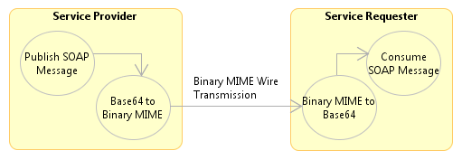
SOAP MTOM is a W3C Recommendation. It describes an abstract feature and a concrete implementation for optimizing the transmission and/or wire format of SOAP messages. The concrete implementation depends on Base64 Encoding, XOP, and MIME specifications for carrying SOAP messages. When implemented, MTOM provides a mechanism of efficiently transmitting binary data, such as images, video, PDF files, and compressed ZIP files between systems. These are the specifications, standards, and recommendations DAWS follows to efficiently send bulk binary data over HTTP. Figure 3 demonstrates the steps involved in transmitting data from Service Provider to Service Requester.
Figure 3: MTOM Transmission Steps

Base64 Encoding
Base64 is an encoding scheme that represents binary data in an ASCII string format by translating it into radix-64 representation (65 textual characters). It is commonly used in email applications via MIME to store complex and binary data in XML. This encoding allows DAWS to include the compressed binary ZIP file of the large dataset in the SOAP message body. A sample SOAP Body with Base64Binary encoded element <data> is shown below:
<Envelope>
<Body>
<data>HdsVeRi0x93YxiOf7Yisjh09…</data>
</Body>
</Envelope>

We can stop here though, because base64 encoded data is approximately 33% larger than the binary data itself. This inflation of the data wastes processing time, network bandwidth, and transmission time. DAWS will need a method to optimize the base64binary encoded data to increase efficiency.

XML-binary Optimized Packaging (XOP)
XOP is a specification that provides a means of more efficiently serializing XML Information Sets that have binary data. It also provides a mechanism to de-serialize the binary data back into the XML Information Set. The benefit of XOP is it allows the binary data part of an XML Infoset to be serialized without going through the XML serlializer. The XML serialization of XML Infoset is text based which means the binary data will have to be encoded using base64. The use of XOP avoids this by extracting the binary data out of the XML Infoset so it can be serialized in a different way. XOP reduces the size of the serialization since base64 encoding is known to increase binary data as much as 33%. This reduction in size increases efficiency for DAWS when transmitting large data sets.

Multipurpose Internet Mail Extensions (MIME)
MIME is an internet standard that extends the format of e-mail to support text in character sets other than ASCII, non-text attachments, message bodies with multiple parts, and header information in non-ASCII character sets. MIME standards also define content types for communication protocols like HTTP. It will be used in our technique of implementing DAWS to define binary data appended to our SOAP message separated by a MIME boundary as shown below:
<Envelope>
<Body>
<data><xop:Include href=”cid:abc123”/></data>
</Body>
</Envelope>
--MIMEBoundary
Content-Type: application/zip
Content-ID: <abc123>

…binary data is here
…
--MIME Boundary

Implementation
This section describes the resources that will be used to implement DAWS.

Platform

DAWS will be a Java Web Service running under Apache Axis2 framework deployed on Apache Tomcat Java Web Server connected to an Apache Derby Database Server. All these components will be installed on an Intel platform running Windows 7 Operating System (OS). In actuality, the platform and OS are independent as long as they can support and run a Java Virtual Machine (JVM) version 6 or above. Information and downloads for Apache Axis2, Tomcat, and Derby can be found at http://axis.apache.org, http://tomcat.apache.org/, and http://db.apache.org/derby. Information and downloads for Java can be found at http://www.java.com .

Development Tools

Development will be done on an Intel machine running Windows 7 OS using Eclipse IDE for Java EE Developers (Helios SR2 Packages). Information and downloads can be found at http://www.eclipse.org/ .

Programming Language and Code Libraries
DAWS will be programmed in the Java programming language. The code libraries required are the Apache Axis2 libraries that come with the framework.

Implementation Procedure
I plan to start by developing high-level use cases and sequence diagrams for the web service. Also during this phase I’ll design the interface using Web Services Description Language (WSDL). Next, I’ll create an analysis model using the modeling features in Eclipse for the Service Requestor and Service Provider which includes operations to query, compress, transmit, parse, and persist the data. Each operation will be modeled as a mediator function controlled by a single mediator object. The mediator object will basically be an aggregate of all the mediator functions. Once I feel I have a working version of the model, I will use the transform feature of Eclipse to generate the skeleton code and begin writing the implementation logic for each class and its methods. I will also use the Axis2 framework to generate the web service implementation classes from the WSDL design. When coding is complete, I will package DAWS as a Service Archive (SAR file) and deploy on the Tomcat server running Axis2 framework.

Schedule
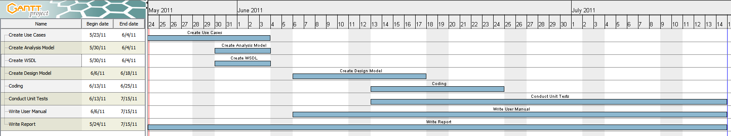

Results
Implementing this solution was a challenge, because it required a Requester (service client), a Provider (web service), and a GUI component to instantiate the service client and make a call to the web service. All of this was necessary in order to demonstrate the capabilities of DAWS. For the web service, I chose Apache Axis2. I chose Axis2, because it is the reference implementation for SOAP and it is open source supported by the Apache license. There are other commercial implementations included in application servers such as WebSphere and WebLogic, but I wanted to use an open one so others are free to implement DAWS and improve it. Axis2 was also chosen because it supported MTOM, a core technology required by DAWS.

The Web Service itself was not too difficult to implement. I created a Plain Old java Object (POJO) called DAWS with only one method, getData(). The POJO was implemented as a web service by using the @WebService annotation just above the class declaration. Annotations such as @WebService signals frameworks like Axis2 to expose public methods as web services. The only argument or parameter required for getData() is a String with the value of the dataset the service client is requesting. For this implementation, there are four data sets; however, DAWS is not limited to four. You could pass in any table name or view to retrieve you bulk data. For our demonstration, our database only contains four tables. The real work of DAWS is done by DataServiceImpl.class. This class has one public method createCompressDataFile() and one private method compressDataFile(). Method createCompressDataFil() is the all inclusive method. This class is the workhorse, because it has to instantiate an XML Stream Writer, connect to the database (delegated to DAWSDao.class), get the JDBC ResultSet, convert the ResultSet to XML, stream the XML to a file, and then compress the file using a ZIP algorithm. All of this has to be done efficiently using stream readers and writers which prevents storing a great deal of data in memory. Using stream writers is one of the core components that enable DAWS to handle large data sets. It was a challenge to get all this done without consuming all the memory and crashing the VM using conditional loops. Once I figured it out and wrote the code, it appeared simpler than I anticipated.

The Service Client was challenging only because I had to learn the Axis2 API in order to create a DataHandler capable of receiving a binary ZIP file and writing it to disk. The real challenge was finding documentation on how to use the Axis2 API. The online documentation is good, but does not go into detail with MTOM. Through trial and error, I was able to find the right solution. Once again, when I figured out the API, the end code was not complex.

The GUI client was the most time consuming portion of this project. I wanted to use a rich client, because I felt it would better demonstrate the capabilities of DAWs. Since Eclipse was my choice of IDE, I decided to use the eclipse framework called Rich Client Platform (RCP) to implement the practical application to demonstrate DAWs. Although there is a lot of support in the industry for RCP, there are not solid examples on how to write RCP applications. Yeah, there are several “Hello World” examples, but not one to create custom GUIs…at least not for mere mortals. Most documentation is advanced and fell short of what I needed. Again, trial and error was my approach. With trial and error along with luck and a Google editor called WindowBuilder, I was able to create a GUI I believe provides a good demonstration of DAWS.

The greatest lesson learned is to keep up with documentation while you code. Although I was able to complete this project on time, I had to stay up late a few nights toward the end just to catch up on writing this report. The most significant lesson learned on the technical side is to use stream writers whenever working with large sets of text such as XML representing large data sets. Building XML documents in memory will fail because memory is a finite resource. There is a fine balance; however, when it comes to performance. Input/Output to and from disk is much slower that reading and writing to memory. This is where DAWS can be fine tuned. A technique would be to declare a lowest common denominator for memory allocation and tune the application to where it maximizes the required memory but does not exceed it. Another lesson learned is do not try to use temporary file managers to store the data files. This is not a guarantee across OS platforms. It is best to allocate a directory for DAWS to use with read and write access and make it a requirement at install time instead of trying to use system temp directories.

Future Enhancements
The fist enhancement DAWS could use is configuration at install and run time. For this project, DAWS is flexible enough to return any data set passed, but is tied to a particular database. DAWS should be able to be configured to connect to any data source. In addition, a validation component should be added to make sure the data source is available and the data set of the data source is available. Making DAWS more configurable would enable it to be an enhancement to other applications. The most significant one that comes to mind are global logistical applications. These applications have several nodes deployed worldwide that constantly synchronize data to track logistical statuses and inventory. Unfortunately, this data must be protected and is restricted (sometimes) to HTTPS protocol because connectivity is maintained over wireless satellite communications. Currently, these nodes send several small messages over HTTPS, but do not replicate data due to size restrictions. DAWS can solve that by not only sending large data sets over HTTPS, but as compress binary versus inflated encoded text. DAWS is very efficient as the demonstration will prove. Its real value becomes apparent when a system is restricted to HTTPS, must be secure, and has little bandwidth to spare. An idea to extend the DAWS project is to implement a One-Pass Analytics application using MapReduce[6]. DAWS can provide the means of transporting large datasets over HTTP to a One-Pass Analytics application because it uses stream writers to send the compressed data. This would be a practical application for DAWS in a limited environment where there are protocol and bandwidth restrictions as well as tight security requirements.

References
- SOAP Messaging Transmission Optimization Mechanism, Martin Gudgin, Noah Mendelsohn, Mark Nottingham, Herve Ruellan, et. al., Editors. World Wide Web Consortium, 25 January 2005. http://www.w3.org/TR/soap12-mtom/
- SOAP Version 1.2 Part 1: Messaging Framework, Marc Hadley, Noah Mendelsohn, Jean-Jacques Moreau, et. al., Editors. World Wide Web Consortium, 24 June 2003. http://www.w3.org/TR/soap12-part1/
- XML-binary Optimized Packaging, Mark Nottingham, Noah Mendelsohn, Martin Gudgin, and Hervé Ruellan, Editors. World Wide Web Consortium, 25 January 2005. http://www.w3.org/TR/xop10/
- Jacob Ziv and Abraham Lempel; A Universal Algorithm for Sequential Data Compression, IEEE Transactions on Information Theory, 23(3), pp. 337–343, May 1977.
- Tong Ka Iok, K. (2008). Developing Web Services with Apache Axis2. Sydney: TipTec Development.
- "Towards Scalable One-Pass Analytics using MapReduce", Edward Mazur, Boduo Li, Yanlei Diao, Prashant Shenoy. DataCloud 2011

Appendixes
APPENDIX A
Status Reports
A.1 Capstone Project Week 5 Status Report for “A Technique of Sending Bulk Data over HTTP”
Date: 05-Jun-2011

Accomplishments
Activity 1: Create Use Case (23-May-2011 – 04-Jun-2011)
- DAWS Service Provider: Publish WSDL to Service Registry - completed
- DAWS Service Requester: Find Service – completed
- DAWS Service Requester: Bind to Service Provider – completed
- DAWS Service Requester: Request Data – completed
- DAWS Service Provider: Publish SOAP Message – completed
- DAWS Service Requester: Consume SOAP Message – completed

Activity 2: Create Analysis Model (23-May-2011 – 04-Jun-2011)
- Actor Model – completed
- Use Case Model – completed

Activity 3: Create WSDL (23-May-2011 – 04-Jun-2011)
- First Iteration of WSDL – completed

Current Activities
Activity 4: Create Design Model (06-Jun-2011 – 18-Jun-2011)
- DAWS Service Requester: Client Interfaces – in progress
- DAWS Service Provider: Moderator Interfaces – in progress
- Database Access Service (DAS) Interfaces – in progress

Activity 5: Write User Manual (06-Jun-2011 – 15-Jul-2011)
- Data Access Web Service – in progress

Activity 6: Write Final Report (06-Jun-2011 – 15-Jul-2011)
- Data Access Web Service – in progress

Challenges
The challenges are:
- How to write XML result-set file on Service Provider machine and remove after it has been sent to Service Requester. Need a Temporary File Manager.
- How to reduce overhead of connecting to database. Need a generic connection pooler that is not dependent on database vendor. One that will work with Apache Derby.
- How to package full implementation as an application to demonstrate.

The challenges listed above can be resolved and do not place the project at risk.
A.2 Capstone Project Week 7 Status Report for “A Technique of Sending Bulk Data over HTTP”
Date: 19-Jun-2011

Accomplishments
Activity 4: Create Design Model (06-Jun-2011 – 18-Jun-2011)
- DAWS Service Requester: Client Interfaces – complete
- DAWS Service Provider: Moderator Interfaces – complete
- Database Access Service (DAS) Interfaces – complete

Current Activities
Activity 5: Write User Manual (06-Jun-2011 – 15-Jul-2011)
- Data Access Web Service – in progress

Activity 6: Write Final Report (06-Jun-2011 – 15-Jul-2011)
- Data Access Web Service – in progress

Activity 7: Coding (13-Jun-2011 – 25-Jun-2011)
- Data Access Mediator Spec (Interface) – in progress
- Data Access Web Service Input Contract (Interface) – in progress
- Data Access Web Service Client Contract (Interface) – in progress

Activity 8: Coding Unit Tests (13-Jun-2011 – 15-Jul-2011)

Challenges
The challenges are:
- Created a Temporary File Manager for Windows, but not sure how it will perform under a UNIX OS like Mac OSX. Will need to test.
- I decided to create a rich client for the demo application to simplify installation. This involves more work, but I think will better demonstrate the web service capability.
- I need find a server with a static IP to install Tomcat and deploy DAWS for the demo. I can use my laptop, but I do not have a static IP. There are work-arounds for a dynamic IPs such as provide my dynamic IP as an input for the client just before a request is sent, but I rather avoid this if possible.

The challenges listed above can be resolved and do not place the project at risk.
A.3 Capstone Project Week 9 Status Report for “A Technique of Sending Bulk Data over HTTP”
Date: 04-Jun-2011

Accomplishments
Activity 7: Coding (13-Jun-2011 – 25-Jun-2011)

- Data Access Mediator Spec (Interface) – complete
- Data Access Web Service Input Contract (Interface) – complete
- Data Access Web Service Client Contract (Interface) – complete

Current Activities
Activity 5: Write User Manual (06-Jun-2011 – 15-Jul-2011)
- Data Access Web Service – in progress

Activity 6: Write Final Report (06-Jun-2011 – 15-Jul-2011)
- Data Access Web Service – in progress

Activity 7: Coding (13-Jun-2011 – 15-Jun-2011)
- Data Access Mediator (Implementation Class) – in progress
- Data Access Web Service Input (Implementation Class) – in progress
- Data Access Web Service Client (Implementation Class) – in progress

Activity 8: Coding Unit Tests (13-Jun-2011 – 15-Jul-2011) – in progress

Challenges
The challenges are:
- Coding the implementation classes are taking longer than planned. I have pushed out the schedule or Activity 7 (Coding) to 15-Jul-2011 to complete.
- I still have not tested the Temporary File Manager for a UNIX OS like Mac OSX. Will need to test.
- The rich client development to demonstrate the web service capability is a lot of work compared to the rest of the project; however, I still think it is the right decision.
- I decided to create a small slicehost account with a static IP to host the Apache Tomcat server where I can deploy DAWS. It only costs $20 a month which is a small price to pay compared to finding a work around for dynamic IPs.

The challenges listed above can be resolved and do not place the project at risk.
A.4 Capstone Project Week 11 Status Report for “A Technique of Sending Bulk Data over HTTP”
Date: 17-Jun-2011

Accomplishments
Activity 7: Coding (13-Jun-2011 – 15-Jun-2011)

- Data Access Mediator (Implementation Class) – complete
- Data Access Web Service Input (Implementation Class) – complete
- Data Access Web Service Client (Implementation Class) – complete
- Activity 8: Coding Unit Tests (13-Jun-2011 – 15-Jul-2011) – complete

I am happy to say the base coding is complete including unit tests. It took some long nights, but I am happy with the results.

Current Activities
Activity 5: Write User Manual (06-Jun-2011 – 22-Jul-2011)
- Data Access Web Service – in progress

Activity 6: Write Final Report (06-Jun-2011 – 22-Jul-2011)
- Data Access Web Service – in progress

The Rich Client application to demonstrate the capabilities of DAWS is over 80% complete. It just needs some usability enhancements. Aside from that, all major features work.

Challenges
The challenges are:
- Writing the user manual and report is not complete. I will have to push the completion date of the report and manual to this Friday July 22, 2011.
- The Temporary File Manager is no longer needed. I was able to maintain the files using c:\Temp on Windows and /tmp on Unix.
- To properly run the DAWS Rich Client application, the end user will need to be logged in with an account that has read, write, and execute permissions.

The challenges listed above do not place the project at risk.
APPENDIX B
Software Configuration
B.1 Steps to install DAWS Server
** Note: DAWS Server is currently running at http://50.56.72.178/DAWS/services/DAWSService/ for this project demonstration. This is the service endpoint reference for DAWS. For manual installation, please follow the instructions below:

Dependency Files:
JDK 6 or higher (http://www.java.com)
Apache Tomcat 6 or higher (http://tomcat.apache.org)

Project File:
DAWS.war (http://50.56.72.178/Downloads)

DAWS Server is dependent on the server running JDK 6 or higher. The JRE is not enough, it must be JDK. The DAWS.war file is a java web archive compliant with J2EE standards of deploying web applications. It can be installed on any Java Web Server capable of deploying WAR files. For this demo, Apache Tomcat 6 or higher should be used. You can download Apache Tomcat at http://tomcat.apache.org/. Once downloaded, follow the documentation on the Apache Tomcat website on how to install. Be sure to you have Java SDK (not JRE) 6 or higher installed first. If you are unable to receive the DAWS.war file as an attachment to email due to size limitations, go to http://50.56.72.178/Downloads/ and click on the DAWS.war file to download the file.

Once all resource files are downloaded and JDK 6 and Apache Tomcat are installed, follow these steps to install DAWS:

- Copy DAWS.war to the webapps directory where Tomcat is installed (see image below)

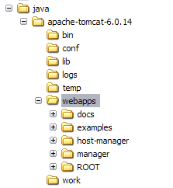

- Open a command prompt and go to the root directory of where Tomcat is installed and type the following command:

  - Windows: {$tomcat-home}\bin\startup.bat

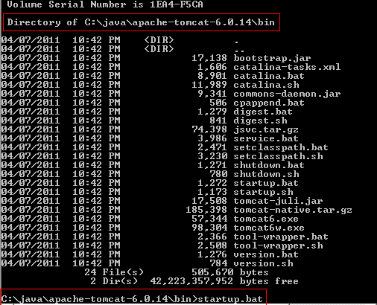

  - Unix: {$tomcat-home}/bin.startup.sh

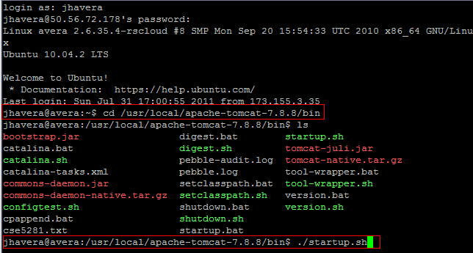

- This will startup Tomcat which will automatically deploy DAWS web application / web service.

B.2 Steps to install DAWS Database
** Note: DAWS Database Server is currently running at jdbc:hsqldb:hsql://50.56.72.178/ for this project demonstration. This is the JDBC connection URL for DAWS Database. The DAWS Server is already configured to connect to the DAWS Database for the demonstration. For manual installation, please follow the instructions below:

Dependency Files:
JDK 6 or higher (www.java.com)
HyperSQL 2.2.5 (www.hsqldb.org) or higher (http://sourceforge.net/projects/hsqldb/files/)

- Follow the documentation on the HyperSQL site on how to install and run in server mode.
- Open a command prompt and go to the root directory of where Tomcat is installed and type the following command:
  - Windows: {$hsqldb-home}\bin\runServer.bat
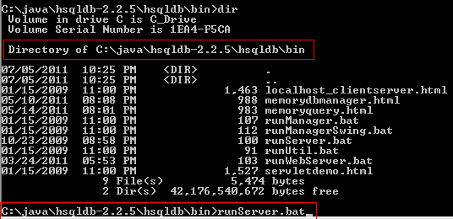

  - Unix: {$hsqldb-home}/bin.startup.sh

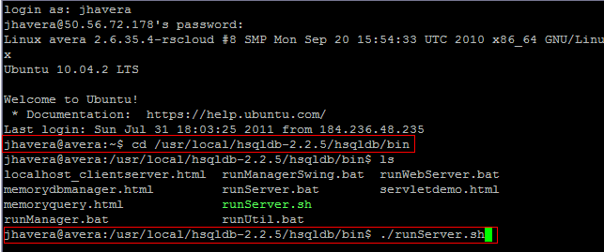

- Execute the following script to build the TESTDATA table:

CREATE TABLE TESTDATA (
ID INTEGER,
FIRSTNAME VARCHAR(50),
LASTNAME VARCHAR(50),
STREET VARCHAR(50),
CITY VARCHAR(50)
);

- Data can be loaded into the table using the DAWS RCP client application.

B.3 Steps to install DAWS RCP Client
Dependency Files:
JDK 6 or higher (http://www.java.com)

Project File:
DAWS-RCP.zip (http://50.56.72.178/Downloads)

DAWS-RCP is a client application for Windows designed to demonstrate a practical purpose and capability of DAWS. Although it is a Java application, a Unix version was not built for this demonstration. To install, please follow these steps:
- Unzip DAWS-RPC.zip file to your hard drive on a Windows machine.
- Go to the install directory and find eclipse.exe in the eclipse subdirectory.
- Double-click the eclipse.exe, and you should see a brief splash screen followed by the main client application:

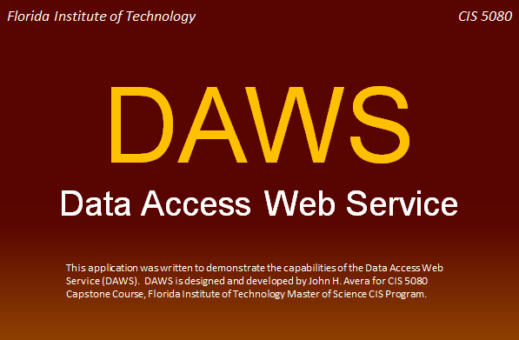

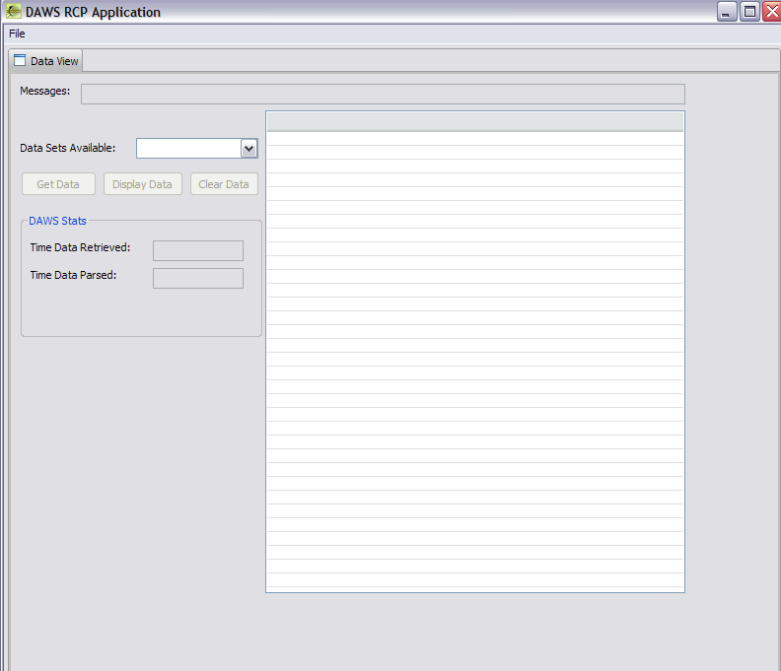
APPENDIX C
Users Manual
DAWS-RCP is a client application for Windows designed to demonstrate a practical purpose and capability of DAWS. Once you have it up and running, follow these steps to demonstrate the capabilities:
- Select TESTDATA in the Data Sets Available combo box:
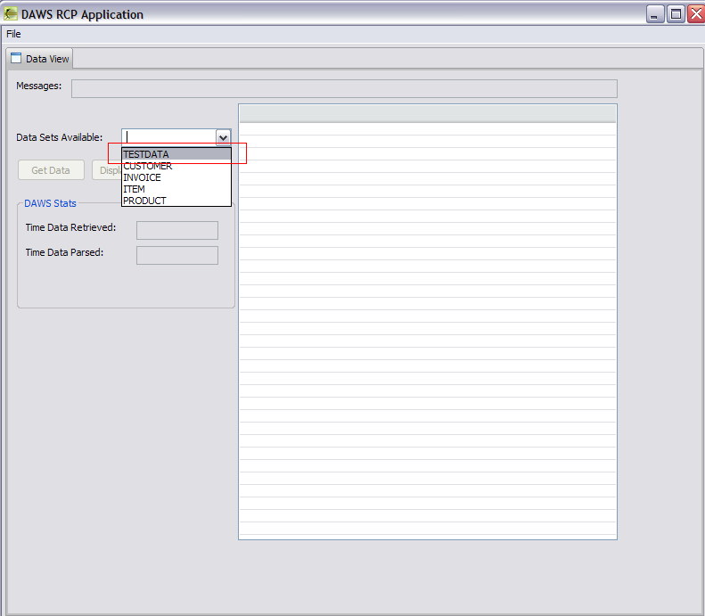
- Click Get Data button:
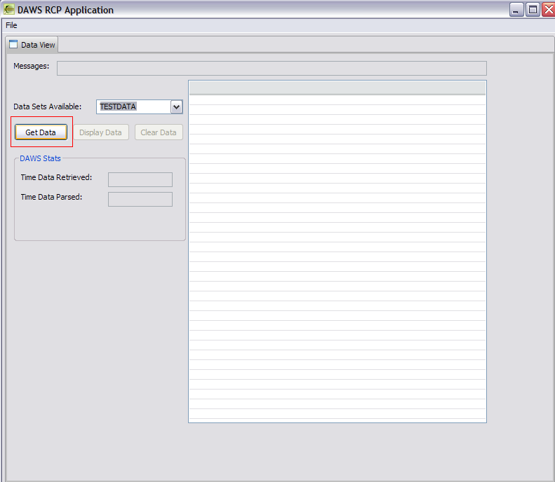
- See results of how long the data file was produced and transferred to the client using DAWS. The screenshot below are the results of running DAWS over a cellular network driving down the road using TESTDATA with 10,000 rows. The results will vary based on bandwidth. For most broadband connection, the performance will be less than 2 seconds.
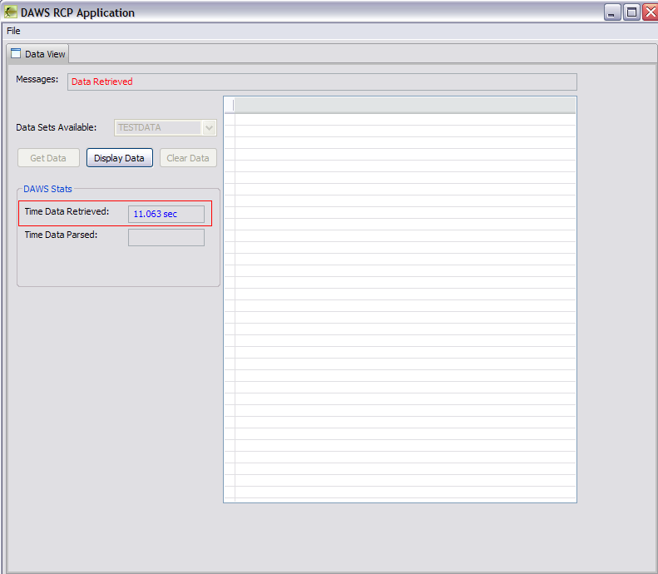

- Optional step is to click the Display Data to see the data once it is parsed on the client side. A time is displayed to perform this function. This would be similar if the client wanted to parse the data file and persist the data to its own database:
